PYTHON REVISION TOUR
COMPUTER SCIENCE (NEW)
CLASS – XII(083)

1 | State True or False: “In a Python program, if a break statement is given in a nested loop, it terminates the execution of all loops in one go.” | 1
2 | Which of the following will delete key-value pair for key = “Name” from a dictionary D1?  a. delete D1("Name") b. del D1["Name"] c. del.D1["Name"] d. D1.del["Name"] | 1
3 | Consider the statements given below and then choose the correct output from the given options:  pride="#G20 Presidency"  print(pride[2:14:2])  Options: (a) 2 ndsr (b) 2 ceieP0 (c) 0 ceieP (d) 2 rsdn | 1
4 | Which of the following statement(s) would give an error during execution of the following code? Why  tup = (20,30,40,50,80,79)  print(tup) #Statement 1  print(tup[3]+50) #Statement 2  print(max(tup)) #Statement 3  tup[4]=80 #Statement 4  Options: a. Statement 1 b. Statement 2 c. Statement 3 d. Statement 4 | 1
5 | Consider the code given below:  X=50  Y=0  def check(Y):  _________ # missing statement  X=Y+X  check(30)  print(X,Y)  Which of the following statements should be given in the blank for #Missing Statement,  if the output produced is (80,0)  options :  (a) global Y (b) global X=50 (c) global X (d) global Y=-30 | 1
Q 6and 7 are ASSERTION AND REASONING based questions. Mark the correct choice as
(a) Both A and R are true and R is the correct explanation for A
(b)Both A and R are true and R is not the correct explanation for A
(c) A is True but R is False
(d)A is false but R is True
6 | Assertion(A): List is an immutable data type  Reasoning(R): When an attempt is made to update the value of an immutable variable, the old variable is destroyed and a new variable is created by the same name in memory. | 1
7 | Assertion(A): Python Standard Library consists of various modules  Reasoning(R): A function in a module is used to simplify the code and avoids repetition. | 1
8 | What will be the output of the following code:  Color = ‘Color helps to give shadow to the picture’  newcolor = Color.replace(‘o’,’#’)  print(newcolor) | 1
9 | Which of following expression(s) is an example of type casting  (a) 4.0 +float(6) (b)5.3 +6.3 (c) 5.0 +3 (d) int(3.1) +7 | 1
10 | The code given below accepts a number as an argument and returns the reverse number. Observe the following code carefully and rewrite it after removing all syntax and logical errors. Underline all the corrections made.  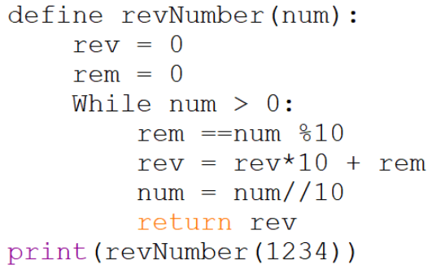 | 1
11 | 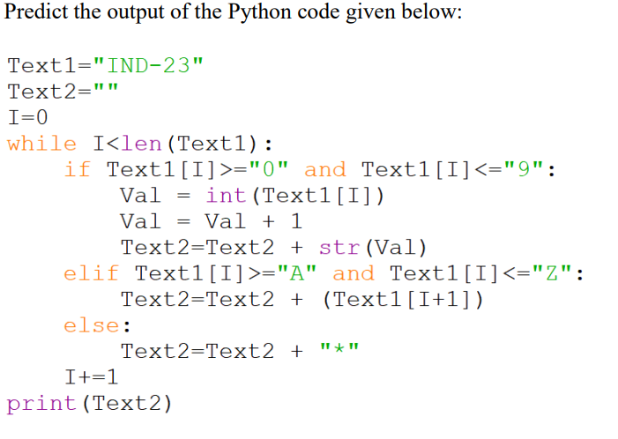 | 2
12 | Write the output of the Code given below:  m = 5  def product(p=2, q=5):  global m  m = p*q+q*p  print(m,end=’#’)  a = 20  b = 5  product(a,b)  product(q=3, p = 2) | 2
13 | Predict the output of the python code given below:  def Difference(N1,N2):  if (N1>N2):  return (N1+N2)  else: return (N2+N1)  Value=[‘a’,’B’,’c’,’D’,’e’,’F’]  for ch in range(5,0,-1):  A=Value[ch]  B=Value[ch-1]  print(Difference(A,B)) | 2
14 | 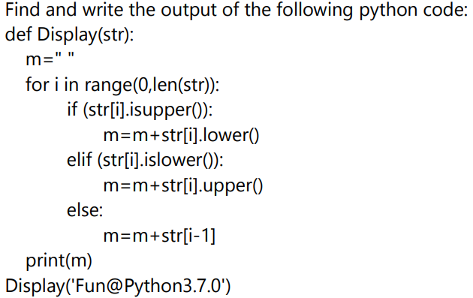 | 2
15 | 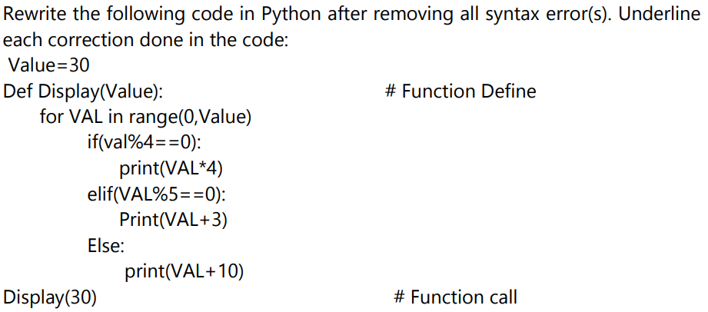 | 2

